***Unix Assignment Questions***

### **1 Basic File Operations:**

* **Q1:** Create a new directory called project in your home directory. Inside the project directory, create two subdirectories named src and bin.
* **Q2:** Create a text file named notes.txt in the src directory and add some text into it using the echo command. Display the contents of the file.

Ans1:

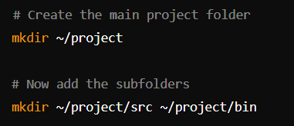

Ans2:

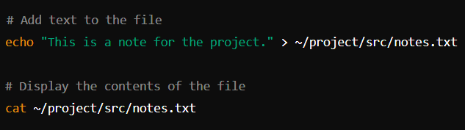

### **2. Working with File Permissions:**

* **Q3:** Create a file named data.txt. Set the permissions so that:
  + The owner can read and write.
  + The group can read.
  + Others have no permissions.
* **Q4:** Change the permissions of data.txt to be readable, writable, and executable by everyone.

Ans3:

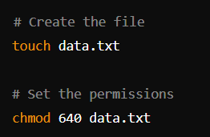

Ans4:



### **3. File Searching and Manipulation:**

* **Q5:** Using the find command, search for all .txt files in your home directory.
* **Q6:** Find all files in the /etc directory that were last modified in the last 7 days.
* **Q7:** Use the grep command to search for the word "error" in the /var/log/syslog file. Display the lines where this word occurs

Ans5:



Ans6:



Ans7:



### **4. Text File Operations:**

* **Q8:** Display the contents of a file report.txt line by line using the cat, more, and less commands.
* **Q9:** Use head and tail commands to display the first 10 and last 10 lines of a file named log.txt.
* **Q10:** Create a file named names.txt containing a list of names. Use sort to display the names in alphabetical order.
* **Q11:** Use the wc command to count the number of words, lines, and characters in a file data.csv.

Ans8:

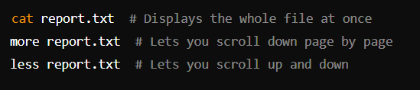

Ans9:

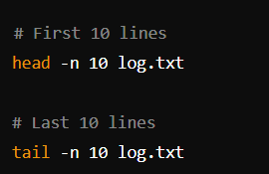

Ans10:

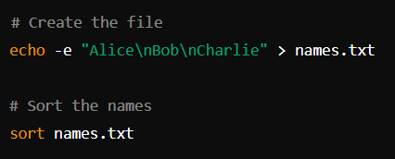

Ans11:



### **5. Process Management:**

* **Q12:** List all running processes using the ps command.

Ans12:



**6. System Information:**

* **Q13:** Display the current date and time using the date command.
* **Q14:** Use the df command to display disk space usage.
* **Q15:** Use the uname command to display your system’s information (e.g., OS type, version).
* **Q16:** Display the current system uptime using the uptime command.

Ans13:



Ans14:



Ans15:



Ans16:



### **7. Network Commands:**

* **Q17:** Use the ping command to check if a remote server (e.g., google.com) is reachable.
* **Q18:** Use the ifconfig or ip a command to display the network configuration of your system.
* **Q19:** Display the active network connections using the netstat command.

Ans17:



Ans18:

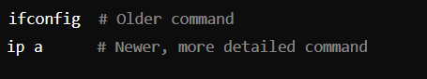

Ans19:

